The Lifecycle of the Butterfly 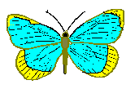

The lifecycle of a butterfly is really interesting and very different from that of animals such as humans, dogs and cats. Butterflies do not give birth to live young and the caterpillar looks very very different from the adult butterfly. When females have been fertilised by the male butterfly, she looks for a safe place to lay her eggs and this is usually under a leaf. The eggs slowly grow into the baby caterpillars which once formed hatch out of the eggs. Then the caterpillars eat and eat lots of leaves to grow read for the next stage. This is when the caterpillar will wrap itself inside their own pod called a chrysalis. Inside this chrysalis the caterpillar transforms from the podgy grub into the beautiful butterfly and the caterpillar has then matured into the adult.

The butterfly lays many eggs as the little caterpillar is food to birds and little mammals. So to make sure that some caterpillars survive to grow into the adult butterfly the female must lay many eggs. The fact that some creatures are the prey of other animals is all part of the process of life. There are animals that are predators, this means they eat other creatures and some are prey.

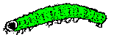

Task: Label the diagram below also put in the arrows that show the life cycle.

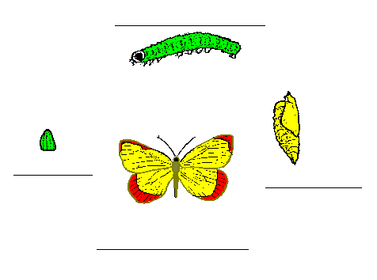

Task 2: Fill in the grids explaining what happens at each stage.

Stage 1.  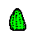  ………………………………… | ………………………………………………………  ………………………………………………………  ………………………………………………………  ………………………………………………………  ………………………………………………………

Stage 2.  ………………………………………… | ………………………………………………………  ………………………………………………………  ………………………………………………………  ………………………………………………………  ………………………………………………………

Stage 3.  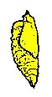  …………………………………… | ………………………………………………………  ………………………………………………………  ………………………………………………………  ………………………………………………………  ………………………………………………………

Stage 4.              

