Year 4 Term 2 (Unit 4D Science)
Solids, Liquids and Gases Assembly

Resources Needed: 1 piece of balsa wood (scored underneath to make sure to make sure it works!)
2 bricks (or suchlike) to place the balsa on for the chop!
1 pack/bottle of table salt
1 bottle of water
2 bowls (in which to pour salt and water)
A4 sheets with examples for quiz (included with this script)
(optional) Goggles/white coats for ‘demonstrators’

*For the solid/liquid/gas groups, I put 6 children in 3 rows of 2 and asked them to imitate the relevant particles i.e. tightly squeezed together and moving side to side a little for the solid. For the liquid 2 pairs and 2 individuals moving in & out of each other, then for the ‘gases’ they whizzed around the hall in 2 directions!
** Numbered for 30 kids, but obviously can be changed.

1______Good morning and welcome to Class __’s assembly.
2______ In our Science lessons, we’ve been looking at
solids and liquids – so we thought we’d share
what we’ve learned so far with you all…
3________ (puzzled) What are solids and liquids?
4________ Well, all stuff on Earth…
3________ (interrupts) STUFF?! Don’t you mean matter? That’s the proper scientific word for it!
__All_____ Oooooh – get him!

4________ Show off – yes o.k.….all matter on Earth is
found in 3 states.
5________ My mum said my dad was in a right state when
he got in last night…
6________ Erm…yes…well, as I said – all matter is found in
3 states. It’s either a solid, liquid or a gas.
7________ Solids keep their shape – unless you exert a
force upon it.

(‘karate’ chop on balsa wood here 8_______)

9________ This is what the particles – tiny bits that make
up all matter – look like in a solid, if we looked
under a really powerful microscope.

(‘solid’ group demonstrates 10, 11, 12, 13, 14, 15)

16_______ They’re really close together and are attracted to each other and they don’t move much.
17_______ Liquids take the shape of what ever container they’re in. They pour and flow.

(pour liquid from bottle into bowl 18_______)

19______ The particles in a liquid behave like this.

(‘liquid’ group demonstrates)

20______ They are a bit further apart than solid particles
and move about a bit more.
21______ Some liquid particles are attached and some are
on their own.
22______ Gas particles are really spread out and move fast
- like this!

(‘gas’ group demonstrates by moving quickly around the hall/room then returning to the stage/front)

23_______ It’s not always easy to group solids and liquids
because some solids act like liquids.
24_______ Look at this salt

(pour salt from packet into bowl 25_______)

26_______ Is it a solid or a liquid?
27_______ It is a solid – but each solid is a very small
piece called a granule or grain and it can flow a
bit like a liquid.
28_______ Now it’s quiz time – are these items solids,
liquids or gases?

(hold cards up – “Yes, well done!” or “Try again” 29)

30_______ Thank you for listening so well to our assembly.

bricks

milk

oxygen

sand
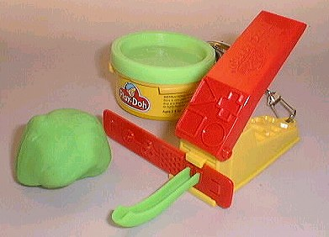

plasticine

