CHANGING STATE

→ heat → heat →
SOLID → LIQUID → GAS
melting evaporation

← cool ← cool ← cool
SOLID ← LIQUID ← GAS
freezing condensation
What have we learnt about solids, liquids and gases?

AIR
We have found out that:
- Air is all around us
- Air has weight
- Air is in soil
- Air floats in water
- Air can act as a force against anything moving. This force is called air resistance.
SOLIDS

Have a fixed shape that does not change unless a force is applied.
This means a solid will keep
its own shape if left alone.
Solids can not
be compressed.

LIQUIDS

A liquid takes the shape of the container it is poured into, but the volume stays the same.
The liquid is pulled toward the bottom of the container by gravity.
GASES

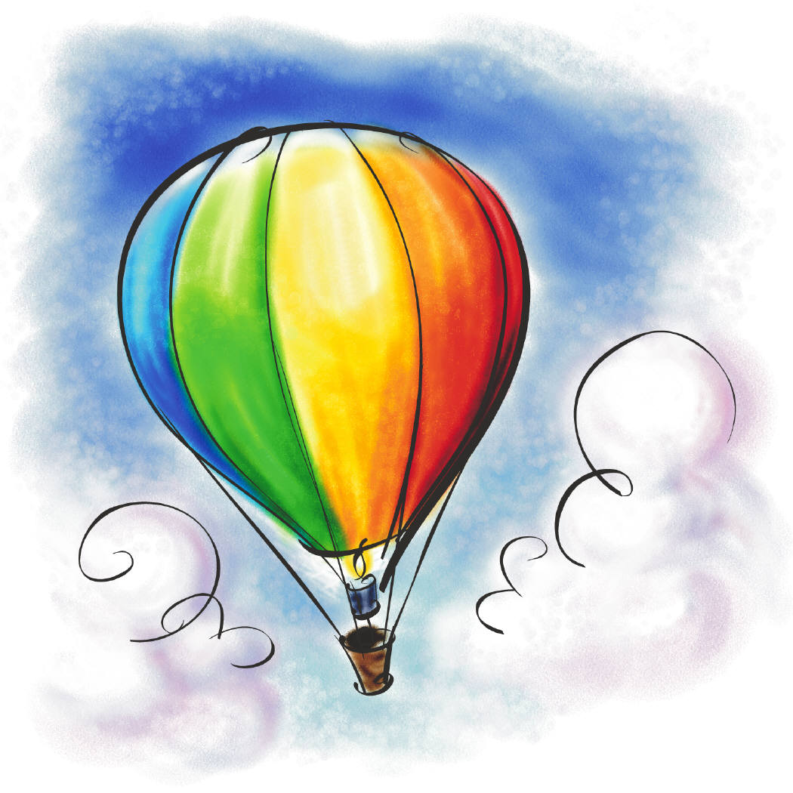
Gases spread out in all directions to fill a space, so they take any shape.
Gases can be compressed.

GASES WE KNOW
Oxygen
(in the air, we breathe it in)

Helium
(In the Sun,
in helium balloons)
Carbon dioxide
(in the air, we
breathe it out)
Hydrogen
(In the Sun)
Methane
(a greenhouse gas)
Neon
(used in
bright coloured lights)
Argon
(In the air)

