Name: Date:
Sort these materials into two groups.
Those that conduct electricity are called conductors and those that do not conduct electricity are called insulators. Test the materials in a circuit to find out.
Try these materials in your circuit.
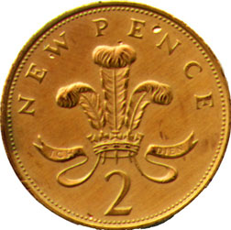
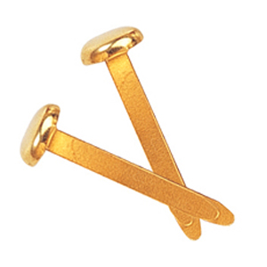

paper fastener
key
paper
2p
rubber

Find some more materials to experiment with e.g. something made of plastic, fabric or metal.

Record your results in the boxes below
Electrical Conductors | Electrical Insulators
What did you find out?
I found out that

