Name ………………………………………

Floating and Sinking

Look at the objects listed in the table below.

If you put them in water do you think they would float or sink? Fill in the table.

Object | Do you think it will float or sink? | When you put it in water did it float or sink?
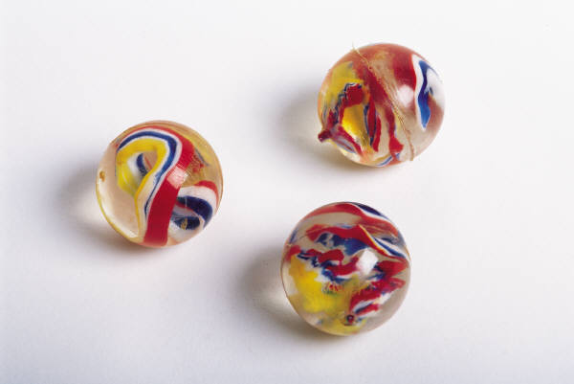
Marble
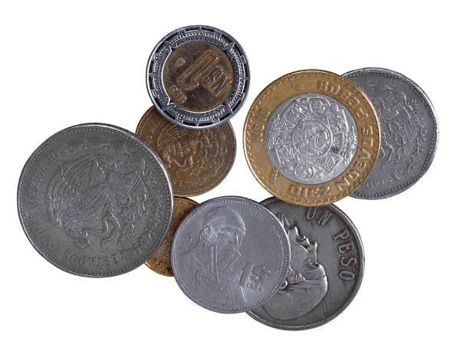
Coin
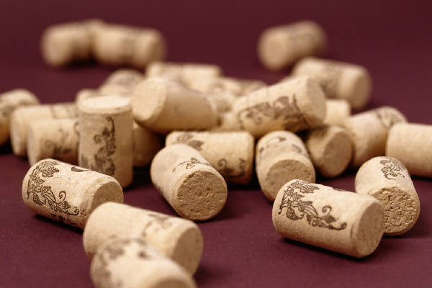
Cork
Ping pong ball
Paper clip
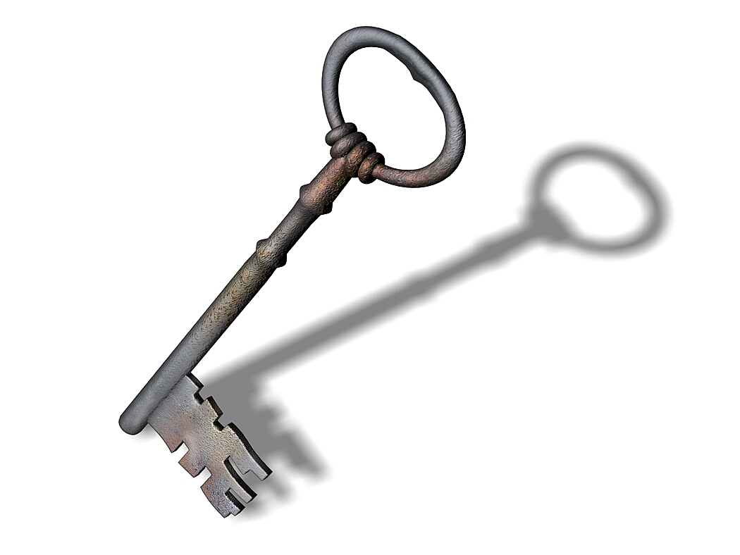
Key

Candle
Rubber
Lollypop stick
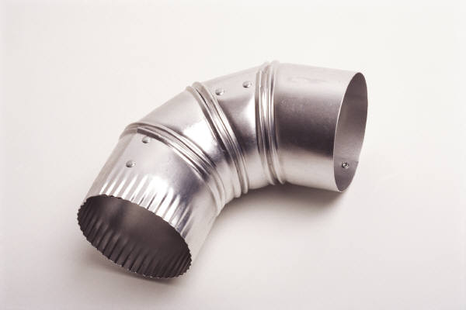
Tin foil

Write about what you have found out.

……………………………………………………………………………………………………………………………………………………………………………………………………………………………………………………………………………………………………………………………………………………………………………………………………………………………………………………………………
……………………………………………………………………………………………………………………………………………………………………………………

