How a plants roots and stem work 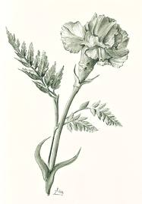

Name: _______________________
Date: ________________________

The plant sucks water up from the soil. The water is needed to keep the plant strong and stops it from going floppy. The water is also needed by the leaves and flowers.

Draw your white carnation and describe what happens if you put it into coloured water (blue is good!) and leave it for an hour.

