investigating
liquid
L.O to know that not all liquids are the same.
L.O to know that liquids look and feel different.
LIQUID | WHAT IT LOOKS AND FEELS LIKE.
Water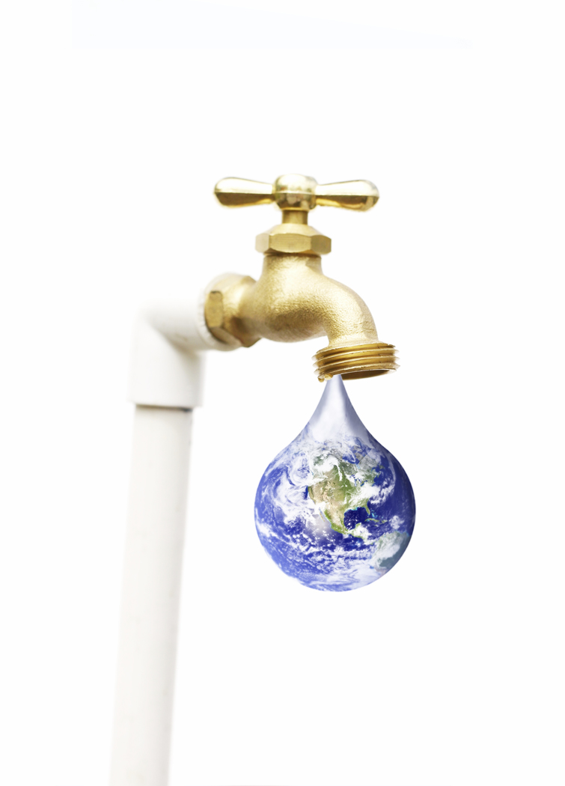
Milk
Coca-cola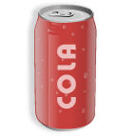
Oil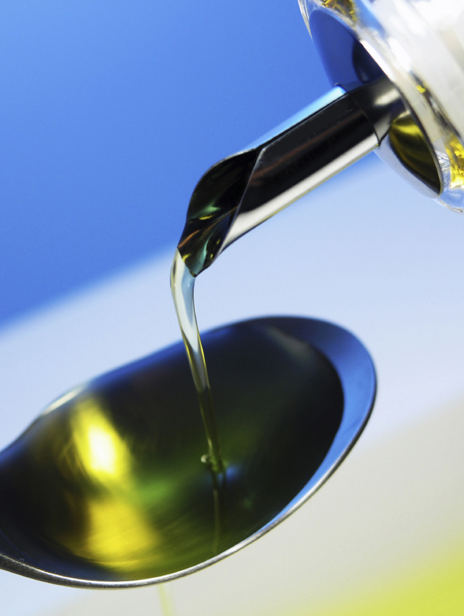
Blackcurrant squash
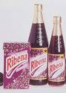
Tea
Orange juice
lemonade
Salty water/ sea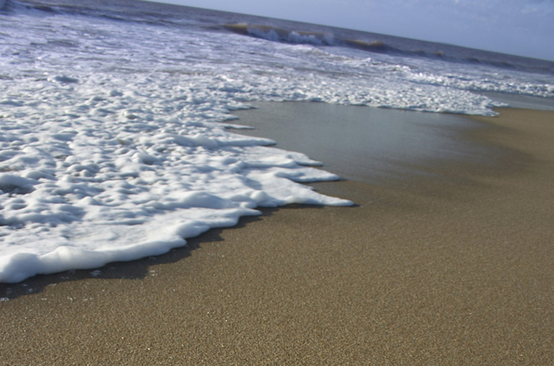

Washing-up liquid
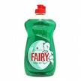

Fill in the gaps with one of the liquids.
Are all the liquids the same? ....................................................................................
I can see through ......................................................................
I can’t see through ..................................................................
.......................................................................................................... is a thick liquid.
.......................................................................................................... has bubbles in it.

