The word you must describe is:
Metal
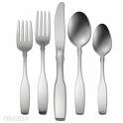
You are not allowed
to say:
Silver
Shiny
Cutlery
The word you must describe is:
Plastic
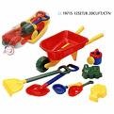
You are not allowed
to say:
Toys
Shaped
Bag
The word you must describe is:
Glass
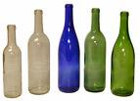
You are not allowed
to say:
Window
Sharp
See-through
The word you must describe is:
Wood
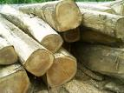
You are not allowed
to say:
Tree
Brown
Furniture
The word you must describe is:
Wool
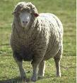
You are not allowed
to say:
Sheep
Jumper
Knitting

