Accelerate  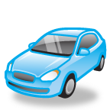 | Move faster
Air | A mixture of gases including oxygen
Air resistance | Force which pushes on objects in air
Amphibians | Animals that live on land and in water. They have wet skin
Artery | Blood is carried away from the heart to the body in arteries. Arteries carry lots of oxygen.
Atom | Tiny particles in solids, liquids and gases. Atoms carry sound to your ear.
Attract | Two magnets will pull each other together if you put the north pole of one magnet to the south pole of the other.
Axis  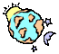 | Where the Earth turns itself around (spins). The Earth’s spins on its axis which gives us night and day
Battery | Where the electricity comes from in a circuit.
Birds  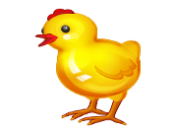 | Animals that have feathers, two legs and a beak.
Boil | Heat a liquid so that it turns into a gas.
Boiling point or boiling temperature | The temperature at which liquid boils and changes into a gas. For water this is 100ºC
Canine  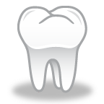 | Tooth that is sharp and pointed for ripping and tearing meat
Carnivore | Animal that eats another animal (secondary consumer in the food chain)
Carpel  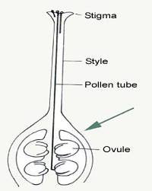 | The female part of the flower
Cell 1  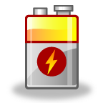 | Another term for battery
Cell 2 | Tiny parts which make up a living thing
Change of state | A change from a solid to a liquid, or a liquid to a gas (or the other way round)
Circuit diagram | A drawing which shows all the components in a circuit and how they are connected
Circulation | When blood travels from the heart to every part of the body and back to the heart
Classify | Put things into groups.
Competition | How living things have to get what they need before other living things get them
Complete circuit | From one end of the battery through the components without any gaps
Compress | When something is squashed
Conclusion | What you have found out
Condensation | When a warm gas cools it changes to a liquid
Conditions | How things are, e.g. cold, light, warm etc.
Gas | A material with atoms that are far apart and that spread to fill any space.
habitat | Where an organism lives.
igneous | Rocks made by heat in volcanoes.
incisor | Tooth for cutting and slicing. (Think of scissors!)
insoluble | A solid that will not dissolve in a liquid.
investigation | A search for proof through a test or experiment.
keys | Short information that helps you to classify things.
leaf  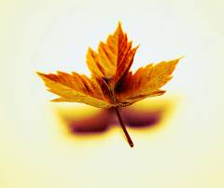 | Part of the plant that makes the food using sunlight.
living | Use MRS NERG to work out if something is living - Move, Respire, Sensitive, Nutrition, Excrete, Reproduce and Grow.
Herbivore | Animal that eats plants. The primary consumer in the food chain.
Impermeable | A substance that does not let water pass through it
Insect  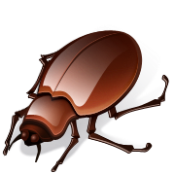 | Animal with six legs and three body parts. Don’t confuse with spiders, woodlice and centipedes; they are not insects, they have more than six legs.
Insulator | A material that won’t let heat or electricity pass through
Irreversible change | A change that cannot be undone, frying an egg
magnetic | A material that is attracted to a magnet.
liquid | A material that has atoms close together and almost in a pattern. A liquid will spread to fill the shape of the container it is in.
mammal | An animal that has fur, gives birth to live young and gives milk.
metal | A material that is a good heat conductor and good electrical conductor.
micro-organism  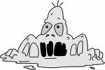 | A living thing (germ) that needs warmth, damp and food to survive. Some micro-organisms are dangerous they give us disease; but some are useful, they help us to make cheese and break down sewage.
muscles | Help us to move. They are fixed to the bones. Muscles work in pairs, one has to contract (shorten) and the other extend (stretch).
Nutrition  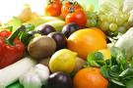 | How living things get energy. Plants make their own food in the leaves using energy from the sun.
omnivore  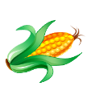 | Animal that eats plants and animals.
orbit | The path a planet makes around the Sun or that the moon makes around the Earth. (The moon takes 28 days to orbit Earth).
ovary | Female part of the plant that keeps the eggs cells safe.
plaque  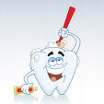 | Dissolved food (mainly sugar) and bacteria that attacks the tooth. Get rid of it by brushing your teeth after meals.
pollen | Tiny grains that carry the genes from the male part of the plant.
Pollution | Waste materials that damage living things.
predict | What you think will happen.
prey | An animal hunted by others.
Producer  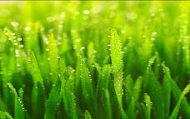 | A green plant that begins the food chain.
pulse | Measures the heart rate; how fast or slow the heart is beating.
repel | When a north of one magnet is put next to a north of another magnet the two magnets push apart. (South and south will repel too).
reptiles  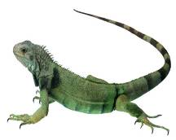 | Animals that have scales and a dry skin.
Reversible change | A material can be changed and then changed back to how it used to be.  E.g. melting an ice-cube is reversible because it can be frozen back into an ice-cube.
Major Organs | Very important body parts that must be kept healthy. Heart, lungs, kidneys, liver, brain stomach and intestines.
Melt | Change a solid to a liquid by heating.
Metamorphic  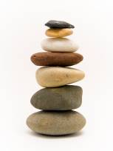 | A rock that has changed because of a lot of heat or pressure.
Molar | Tooth for grinding food. (Ours are at the back of the mouth).
Newton | Force is measured in Newtons. 1N will lift 100g.
Observe | Watch and look carefully.
Opaque | An object that light can’t pass through, so you can’t see through it.
Organism | A living thing, any plant or animal.
Pitch | How high or low a sound is. High pitch is caused by short, tight and thin objects vibrating fast.
Poles | There are two poles on a magnet, the north pole and south pole.
Pollinate | When the pollen from the male part of the plant lands on the female stigma.
Predator | An animal that hunts others to kill and eat them.
Pressure | The force over an area. E.g. a drawing pin head is a large area you push your force on to drive the thin part into a wall.)
Primary consumer | An animal that eats plants (herbivore).
Protein  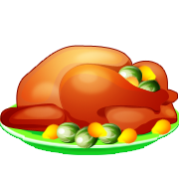 | Food that builds muscle
Reflection | When light rays (which travel in straight lines) bounce off objects. Shiny surfaces will send a reflection of us into our eyes.
Reproduce | When male and female genes join together to make a new life.
Respire | using oxygen to turn food into energy.
Roots | Part of the plant that take in nutrients and water. They keep the plant stable.
Saliva | A liquid in our mouth which kills germs on food and makes food easy to swallow.
saturate | When a liquid can’t dissolve any more solids and you can see the solids in the liquid.
Sedimentary | Rock made by layers settling on top of each other.
Sieving | A way to separate solids of different sizes.
sensitive | Living things are sensitive to their environment. If their environment is changed or damaged their life is affected.
sepal | Part of the plant that protects the young flower (bud) until it is ready to reproduce.
Shadow  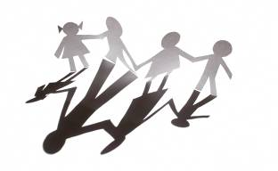 | When light can’t pass through an object (an opaque material), the area behind the object is dark and this is a shadow.
Skeleton  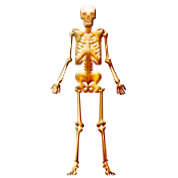 | Our frame to hold us up, protect some organs and help us to move. It grows with us and can mend when broken.
Soil | Tiny pieces of rock and decomposed material from things that once lived.
solar system | A group of planets that orbit the Sun. The Sun is a star. The planets in our solar system are Mercury, Venus, Earth, Mars, Jupiter, Saturn, Uranus and Neptune. Pluto is no longer considered a planet
Solid | A material that has atoms very close together and in a neat pattern. A solid will keep its own shape.
soluble | = A solid that will dissolve in water. (Lots of headache tablets are soluble, watch out for the adverts on T.V. when they drop the tablets into water and they fizz.)
sound | You will only get sound when something vibrates. The vibration makes the atoms in solids, liquids and gases compress and extend, so they carry the sound to your ear.
stamen | Name for the male sex organs of a plant, (the anther and filament).
stem | Part of the plant that takes the nutrients and water to all the other parts.
style | Female part of the plant that takes the pollen down to the egg in the ovary.
Sphere | A 3D rounded object. The Sun, moon and Earth are nearly spheres.
State | Solid liquid or gas. A material can be in any of these three states.
Stigma | Female part of the plant that is sticky so that pollen will stick to it.
Switch  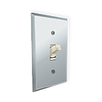 | In some circuits, the switch can be used to stop electricity making a circuit and in others the switch is used to complete the circuit.
Vibration | The movement of an object when a force has been used  No vibration = silence
Virus | A type of microbe
upthrust | The force that pushes up in water.
vacuum | A place where there is no solid, liquid or gas and so there is silence, as there are no atoms to carry the sound.
vein | Blood vessel that carries blood back to the lungs to excrete the carbon dioxide.
water cycle  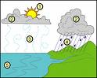 | Water recycled through evaporation or condensation.
Weight  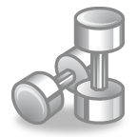 | The force pulling down on a mass due to gravity.
Vertebrate | An animal with a backbone.
Volume | How loud or quiet a sound is.
Consumer | An organism that consumes food and does not produce it
Conductor | Lets heat or electricity pass through it
Degrees Celsius | Unit in which temperature is measured
Describe | Write how something has happened
Digestion | How food is broken down into tiny pieces so that it can be carried in the blood
Dispersal | Spreading seeds far from the parent plant
Dissolve | When you add a solid to a liquid, the solid ‘seems to disappear’
Ear drum | The part of the ear that vibrates for us to hear sound
Echo | Some solids are too thick for all the sound waves to travel through so some sound is reflected back and you hear the same sound again but quieter
Energy | Effort needed
Environment | The surroundings for a living thing
Evaporation | When liquid is heated and it turns into a gas
Evolve | How things change so that they don’t become extinct
Excrete | When living things gets rid of waste so that it wont be poisoned
Extend | When something stretches
Filtering | A way to separate solids from liquids using filter paper
Fish | An animal that has gills, fins and scales
Food chain/web | How energy is passed from one living thing to another
Force | A push, pull or twist that has an effect on an object making it  1. start to move  2. move faster  3. Stop moving  4. change shape  5 change direction
Force meter | Equipment used to measure how much force is needed to move an object
Fossil | Found in rocks, it is proof that something lived long ago
Freeze | Change a liquid into a solid by lowering the temperature
Friction | The force that tries to stop an object from moving
Function | What something is used for

