|  |  |  |
| --- | --- | --- |
| Object | Yes | No |
| [http://t0.gstatic.com/images?q=tbn:ANd9GcSK2pCZP0be6jI61N6YWd3l0iOyzn64zrq7eaEfj6awHuLKNBblkA](http://www.google.co.uk/imgres?q=rock&hl=en&qscrl=1&rlz=1T4GGHP_en-GB___GB457&biw=1280&bih=629&tbm=isch&tbnid=2ecgZTeAXZqSmM:&imgrefurl=http://catholicinasmalltown.wordpress.com/2012/05/28/on-the-rock-in-my-pocket/&docid=DoV5Fs752x5jdM&imgurl=http://catholicinasmalltown.files.wordpress.com/2012/05/rocks-pebbles-lg.jpeg&w=460&h=360&ei=-cqiUKm7A8aLswaIrICIBg&zoom=1&iact=hc&vpx=289&vpy=248&dur=1040&hovh=199&hovw=254&tx=126&ty=126&sig=114110290053831821866&page=2&tbnh=148&tbnw=171&start=18&ndsp=26&ved=1t:429,r:18,s:20,i)  Pebbles |  |  |
| http://www.moderngent.com/media/sponge_466x389.jpg  Sponge |  |  |
| https://encrypted-tbn2.gstatic.com/images?q=tbn:ANd9GcToTtXLS7oCyVuu3pIxb1fTfkUEkNdQU4BwElBvpBU3OXqmWhFXK9jN7VRX  Corks |  |  |
| http://media.treehugger.com/assets/images/2011/10/paperclips.jpg  Paper Clips |  |  |
| http://4.bp.blogspot.com/-caJSYZY8mvs/UIuJysRYysI/AAAAAAAAEP8/PPAyRNgOmgg/s1600/pennies6.jpg  Pennies |  |  |
| http://1.bp.blogspot.com/-1OaImXuhQII/UGFLCWj6AII/AAAAAAAAByo/StexeM0CWwA/s400/legos.jpg  Lego Bricks |  |  |
| https://encrypted-tbn3.gstatic.com/images?q=tbn:ANd9GcRH_eZudivvMYcSJJLnLo2iEvqjKrIWJVGCFte5ADYDwVMA5irMXw  Marbles |  |  |
| https://encrypted-tbn1.gstatic.com/images?q=tbn:ANd9GcSlVlgojv7l1mJ0ikNcQ1sz22nOxQdd8BjMNUaAChATBxUCHHHoCw  Plastic Spoon |  |  |

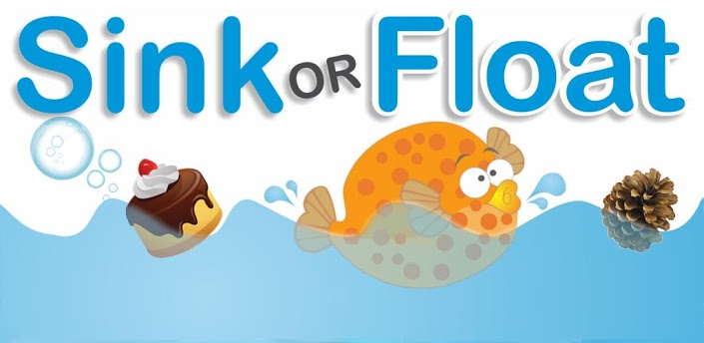

Which of these objects sinks or floats? Test them out using the water tank to find out. Tick the box; **yes** or **no**!

Can you test some other objects to find out if they sink or float?