Switches help control the flow of electricity through a circuit

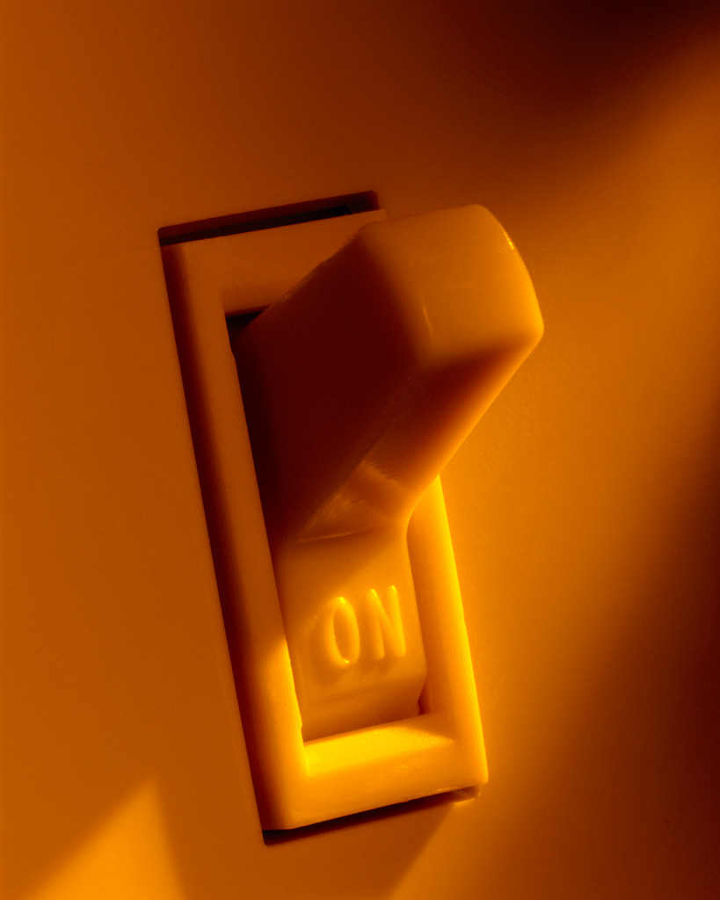
Switch ON

Turning a switch on closes the switch. This completes the circuit and allows electricity to flow through the lamp.

Switches help control the flow of electricity through a circuit
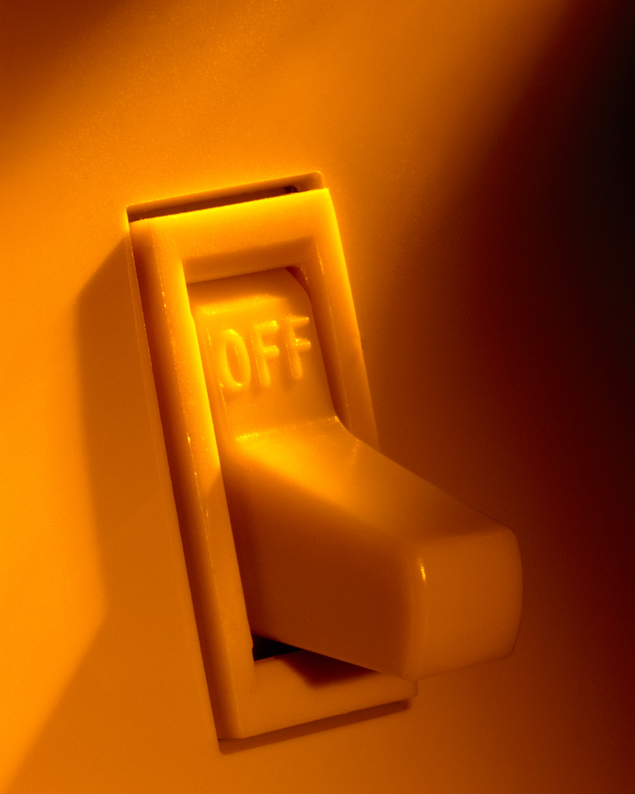
Switch OFF


Turning a switch off opens the switch. This breaks the circuit and doesn’t allow electricity to flow through the lamp.

Circuit Diagram
What are the components in this circuit?
______________________________________
______________________________________
Will electricity flow through this circuit?
Yes No

What is missing from this circuit to make it work?
________________________________
________________________________

Draw a diagram to complete the circuit that will allow the electricity to flow.

Circuit Diagram
What are the components in this circuit?
______________________________________
______________________________________
Will electricity flow through this circuit?
Yes No

What is missing from this circuit to make it work?
________________________________
________________________________

Draw a diagram to complete the circuit that will allow the electricity to flow.

Circuit Diagram
What are the components in this circuit?
______________________________________
______________________________________
Will electricity flow through this circuit?
Yes No

What is missing from this circuit to make it work?
________________________________
________________________________

Draw a diagram to complete the circuit that will allow the electricity to flow.

Circuit Diagram
What are the components in this circuit?
______________________________________
______________________________________
Will electricity flow through this circuit?
Yes No

What is missing from this circuit to make it work?
________________________________
________________________________

Draw a diagram to complete the circuit that will allow the electricity to flow.

