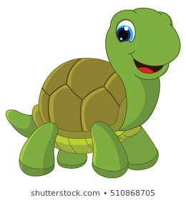

What colours and patterns do you think you will need to use to complete your outline?

Do you think it is effective in hiding it from predators? Can you spot it in the different landscapes?

What habitat do you think the tortoise lives in based on its shell?

What habitat do you think the tortoise lives in based on its shell?

Do you think it is effective in hiding it from predators? Can you spot it in the different landscapes?

What colours and patterns do you think you will need to use to complete your outline?

**Camouflage**

**Colour**

**Pattern**

**Shape**

**Features**

**Habitat**

**Food**

**Background**

**Environment**

**Offspring**

**Parents**

**Characteristics**

**Adaptations**

**Organism**

**Inheritance/ Inherited**

**Camouflage**

**Colour**

**Pattern**

**Shape**

**Features**

**Habitat**

**Food**

**Background**

**Environment**

**Offspring**

**Parents**

**Characteristics**

**Adaptations**

**Organism**

**Inheritance/ Inherited**

**Camouflage**

**Colour**

**Pattern**

**Shape**

**Features**

**Habitat**

**Food**

**Background**

**Environment**

**Offspring**

**Parents**

**Characteristics**

**Adaptations**

**Organism**

**Inheritance/ Inherited**

**Camouflage**

**Colour**

**Pattern**

**Shape**

**Features**

**Habitat**

**Food**

**Background**

**Environment**

**Offspring**

**Parents**

**Characteristics**

**Adaptations**

**Organism**

**Inheritance/ Inherited**

**Camouflage**

**Colour**

**Pattern**

**Shape**

**Features**

**Habitat**

**Food**

**Background**

**Environment**

**Offspring**

**Parents**

**Characteristics**

**Adaptations**

**Organism**

**Inheritance/ Inherited**