1.  What is the name given when seeds produce tiny shoots and roots? | 2.  Which 3 conditions are needed for seeds to start growing? | 3.  Which part of the flower produces pollen?
4.  What pollinates a yellow dandelion? | 5.  Name the male part of a flower. | 6.  Name the female part of a flower.
7.  Which part of the flower attracts insects? | 8.  How are the seeds of strawberries dispersed? | 9.  How are these seeds dispersed?  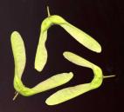
10.  How is this barley pollinated?  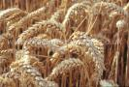 | 11.  What do we call the spreading out of seeds from the parent plant? | 12.  How is this coconut dispersed?  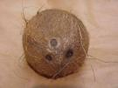
13.  How are these seeds dispersed?  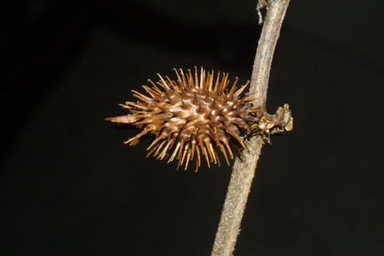 | 14.  What do we call the joining of a pollen grain with an ovule? | 15.  What comes between child and adult in the human life cycle?
16.  What do we call any animal that has died out altogether? | 17.  How long does a human baby take to develop before it is born? | 18.  How long does a mouse baby take to develop before it is born?
19.  What do we mean by the gestation period of an animal? | 20.  What is the Scientific name for the place where a baby develops? | 21.  What do we call the sticky or hairy part of the flower where pollen lands?
22.  How long does an elephant baby take to develop before it is born? | 23.  What do we call the transfer of pollen from one flower to another? | 24.  Why are lots of flowers brightly coloured?
25.  What does the ovary of a flower contain? | 26.  Describe flowers pollinated by the wind. | 27.  Name the 2 things which join to make a seed.
28.  How is this dandelion seed dispersed?  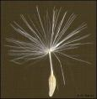 | 29.  How are tomato seeds dispersed?  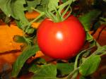 | 30.  Which needs caring for the longest, calf, puppy or human baby?

Year 5 Treasure Hunt Life Cycles pupil answer sheet

Name _______________________ Date_____________

1 | 2 | 3
4 | 5 | 6
7 | 8 | 9
10 | 11 | 12
13 | 14 | 15
16 | 17 | 18
19 | 20 | 21
22 | 23 | 24
25 | 26 | 27
28 | 29 | 30

Year 5 Treasure Hunt Life Cycles teachers answer sheet

Name _______________________ Date_____________

1 germination | 2  air water and warmth (not light) | 3 stamen / anther
4 insects or named insect e.g. bee | 5 stamen /anther | 6 ovary/carpel/pistil /  (stigma)
7 petals (or nectary) | 8 by birds or animals (in their droppings) | 9 by wind
10 by wind | 11 seed dispersal | 12 by water
13 hooked onto animal fur | 14 fertilisation | 15 adolescent / puberty
16 extinct | 17 9 months/40 weeks | 18 less than 3 weeks / 19 days
19 the time taken for baby to develop in the uterus/womb | 20 uterus | 21 stigma
22 approx 640 days / 90 weeks / nearly 2 years | 23 pollination | 24 to attract insects to pollinate them
25 ovules | 26 dull in colour | 27 pollen and ovule
28 by wind | 29 birds/animals (in their droppings) / gardeners collect seeds to plant | 30 human baby

